Online training for CHOICES 2013 is available in the Statewide Learning Management System (SLMS). You must first sign in to the SLMS to access these classes.

Need to create an SLMS account?

If you do not have an SLMS account, visit the OPWDD Training Opportunities page for instructions on creating an account and using the SLMS.

Signed in and ready to enroll?

After you have signed in to the SLMS, follow these instructions:

- Select “Find Learning” from the Quick Links menu
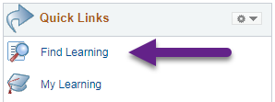
- On the left you will see a “Filter by” menu. Under the category section, select “More…” and then select “CHOICES”
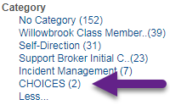

- Select the button for the class you wish to access.

- You will be taken to the Review Information page. Select the button.

- Select the “Launch” link on the bottom left to access the class now.

- To access the class later, sign in to the SLMS and select My Learning from the Quick Links menu. This will bring you to a list of all learning that you have enrolled in or completed.

